Through the Bible: West Angeles Church of God in Christ, Discipleship
Bible Reading Plans 2023, From Bible Study Tools

Click the link to go to the webpage for the readings.

New Testament Bible Reading Plan
Read straight through the New Testament in 90 days.
90 DAYS TO COMPLETE ESTIMATED COMPLETION: MARCH 13, 2023
https://www.biblestudytools.com/bible-reading-plan/new-testament-in-ninety-days.html

Classic Bible Reading Plan
Read 3 passages each day, starting with Genesis, Psalms, and Luke. From the original Bible Study Tools reading plan.
365 DAYS TO COMPLETE ESTIMATED COMPLETION: DECEMBER 13, 2023
https://www.biblestudytools.com/bible-reading-plan/classic.html

Stay-on-Track Bible Reading Plan
If you have trouble staying on track, this one-year plan will help. There are readings only on the weekdays, with weekends free to catch up or get ahead.
364 DAYS TO COMPLETE ESTIMATED COMPLETION: DECEMBER 12, 2023
https://www.biblestudytools.com/bible-reading-plan/stay-on-track.html

Old Testament and New Testament Bible Reading Plan
Read one passage from the Old Testament and one from the New Testament each day.
365 DAYS TO COMPLETE ESTIMATED COMPLETION: DECEMBER 13, 2023
https://www.biblestudytools.com/bible-reading-plan/old-testament-and-new-testament.html

Thematic Bible Reading Plan
This Bible reading schedule is thematic or connective in nature. The goal is to make as many associations as possible between the different parts of Scripture while still reading individual books of the Bible from start to finish. Only the Psalms are not read in consecutive order. The Psalms are individually apportioned throughout the year to increase the number of connections that can be observed and appreciated.
Copyright 2012 Craig J. DesJardins
https://www.biblestudytools.com/bible-reading-plan/thematic.html

Sample Readings:
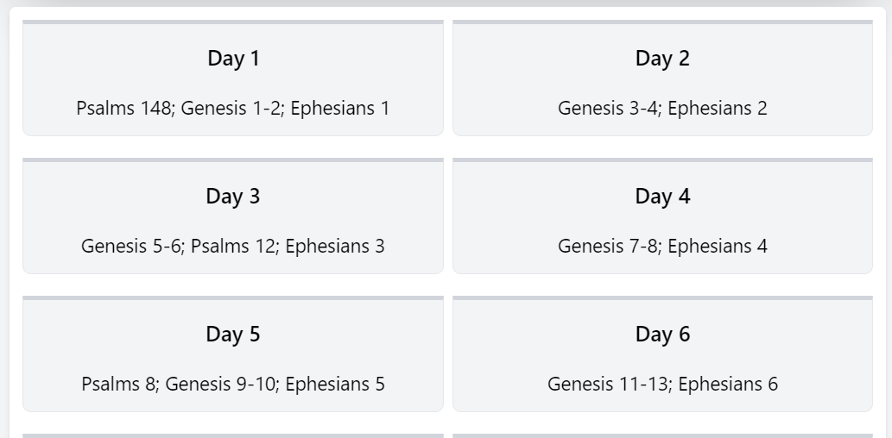

The Busy-Life Bible Reading Plan
If your life is busy, this plan will help you get through the Bible at a pace that works for you. You’ll read a short selection each day and complete the Bible in two years.
720 DAYS TO COMPLETE ESTIMATED COMPLETION: DECEMBER 02, 2024
https://www.biblestudytools.com/bible-reading-plan/busy-life-plan.html

